Common injuries and their causes: Fingers and hands are injured more than any other part of the body. Many times these injuries occur due to lack of an understanding of the hazards that exist or lack of Personal Protective Equipment.

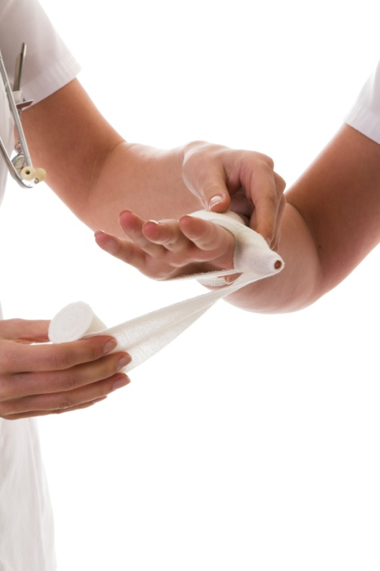
Personal protective equipment (PPE): PPE is designed to guard against any risk present in the workplace. This can be things like molten metal, falling debris, electric shock, etc. Injuries occur when employees choose not to wear designated Personal Protective Equipment or use the wrong type of equipment.
Important pointers on how to avoid common injuries:
- In most cases, gloves have to be used to prevent hand injuries.
- For each job, complete a written Hazard Assessment to ensure that the proper kind of protection is always available for the various exposures.
- Before handling, inspect materials for slivers, jagged edges, burrs, and rough or slippery surfaces.
- Get a firm grip on the object.
- Clear a path of travel and a set point.
- In the case of repetitive motion tasks, be aware that gloves or other PPE can restrict movement which results in greater stress. This must be accounted for.
- Keep fingers away from pinch points when setting down materials.
- Care should always be taken when wearing gloves while working with or around rotating machinery.
- When handling lumber, pipes, or other long objects, keep hands away from the ends to prevent them from being pinched or from sharp edges.
- Wipe off greasy, wet, slippery, or dirty objects before trying to handle them.
- Keep hands free of oil and grease.
- If injuries do occur have them treated immediately. Cuts or scratches can become infected unless properly cared for.
- Report accidents immediately; following procedures for initial response and containment of the incident.

This form documents that the training specified above was presented to the listed participants. By signing below, each participant acknowledges receiving this training.

Organization: Date:

Trainer: Trainer’s Signature:

Class Participants:

Name: Signature:

Name: Signature:

Name: Signature:

Name: Signature:

Name: Signature:

Name: Signature:

Name: Signature:

Name: Signature:

Name: Signature:

Name: Signature:

Name: Signature:

Name: Signature:

Name: Signature:

Name: Signature:

Name: Signature:

Name: Signature:

